ABC’s Inventory Management System

Test Script

Table of Contents

SPT001- Search Product Using Existing Product Code 3

Result Screenshots 3

Data Set 1 4

Data Set 2 6

Data Set 3 9

SPT002- Search Product Using Unknown Product Code 11

Result Screenshots 12

Data Set 1 12

Data Set 2 15

Data Set 3 17

SPT003- Search Product Using Existing Product Item Code 19

Result Screenshots 20

Data Set 1 20

Data Set 2 21

Data Set 3 23

SPT004- Search Product Using Unknown Product Item Code 24

Result Screenshots 25

Data Set 1 25

Data Set 2 26

Data Set 3 28

SPT005- Click on Search button without entering any Product Item Code or Product Code values 29

Result Screenshots 30

SPT006- Test output when both Product Code and Product Item Code field are filled to search for a product. 31

Result Screenshots 32

Data Set 1 32

Data Set 2 34

Data Set 3 37

# SPT001- Search Product Using Existing Product Code

|  |  |  |  |  |  |
| --- | --- | --- | --- | --- | --- |
| **Test Name** | | Test Search Product Using Existing Product Code (Test Case SPT001) | | | |
| **Use Case Tested** | | Search Product | | | |
| **Test Description** | | This test tests if the system can retrieve product item details and contents in each location using a known product code that the product item belongs to. | | | |
| **Pre-Conditions** | | Meta data must exist, product and product details like product code, product item code, location ID and so on must exist. | | | |
| **Post-Conditions** | | Matching product on each location displayed through product code i.e. matching product is displayed through which product items belonging to the product is viewed. | | | |
| **Notes** | | This test assumes that the user knows the product code exists.  This test allows users to view product items using a product code. | | | |
| **Result (Pass/Fail/Warning/ Incomplete)** | | Pass | | | |
|  | **Test Step** | | **Expected Test Results** | **P** | **F** |
| 1. | Open the ABCInventoryClient.exe file | | ABCInventoryClient system launches. | P |  |
| 2. | Type in the existing product code that is known by the user in the Product Code field of the system. | | System waits for the user to hit enter or click on the ‘Search’ button. | P |  |
| 3. | Hit enter or click on the ‘Search’ button. | | Product with matching product code is displayed with all other product details like total quantity, price, name, etc. along with the location details separated according to the location. | P |  |
| 4. | Click on details to check product item details in the desired location. | | Product Items’ details belonging to the product in the location that was selected is displayed. | P |  |

## Result Screenshots

The screenshots of the result on each test step for each data set are given below:

### Data Set 1

|  |  |
| --- | --- |
| **Test Data Table** | |
|  | **Input Data** |
| **Product Code** | S1 |
| **Location ID** | STR1 |
| **Location Name** | Oxford Store |

**Step 1:**

* User opens the Search Product interface

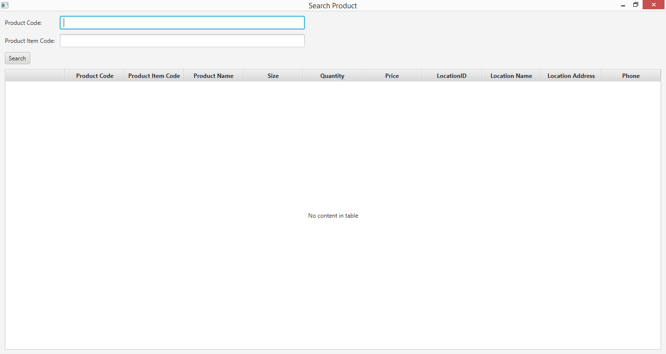

**Step 2:**

* User inputs “S1” to the Product Code field

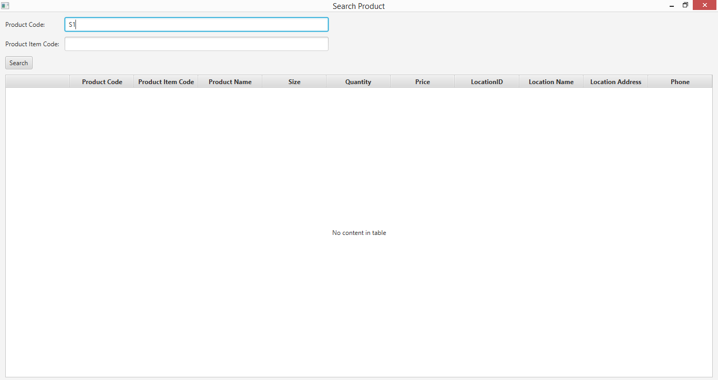

**Step 3:**

* System display the details of matched product
* User selects the “Detail” button of the matched product in Location STR1

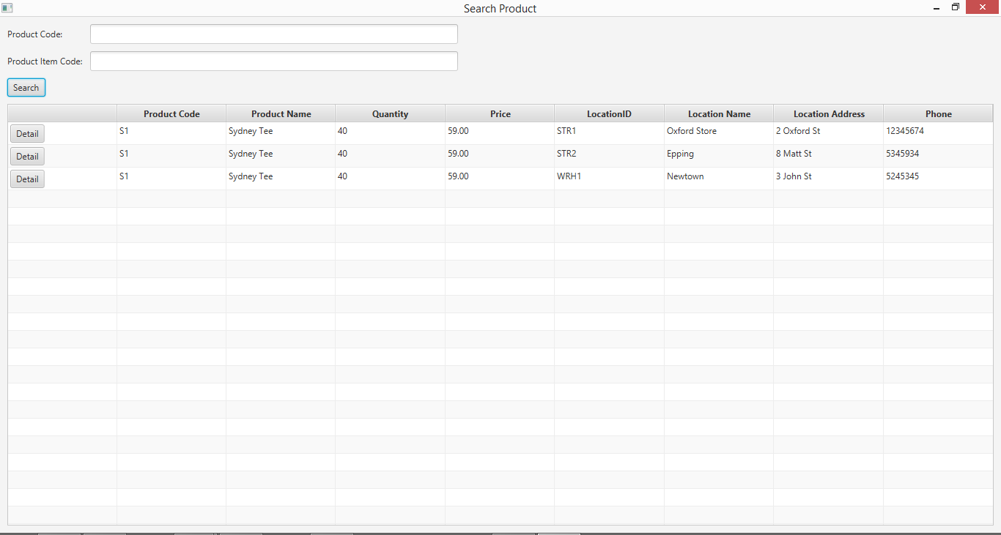

**Step 4:**

* System display the details of matched product items of selected product in STR1.

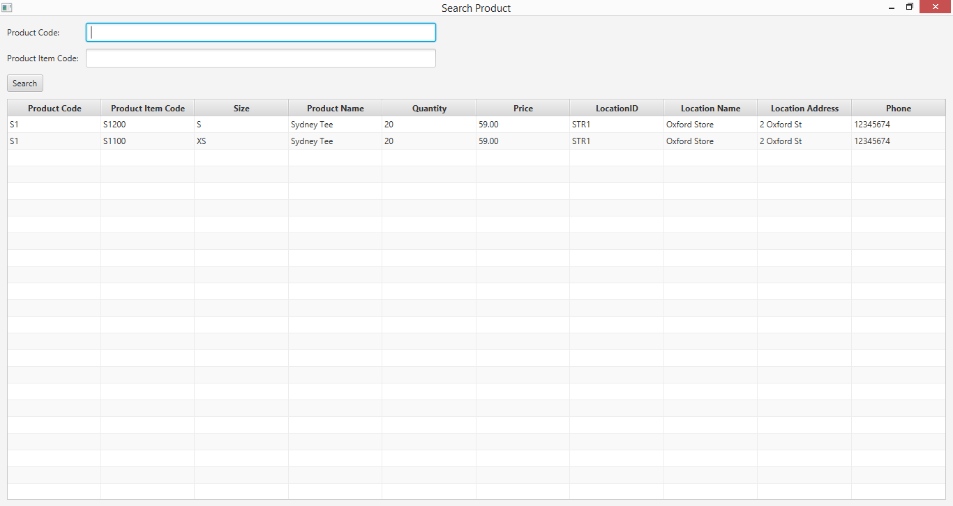

**Test Search Product Using Existing Product Code (Test Case SPT001) for Data Set 1:** **PASS**

### Data Set 2

|  |  |
| --- | --- |
| **Test Data Table** | |
|  | **Input Data** |
| **Product Code** | S1 |
| **Location ID** | WRH1 |
| **Location Name** | Newtown |

**Step 1**

* User opens the Search Product interface



**Step 2**

* User inputs “S1” to the Product Code field



**Step 3**

* System display the details of matched product
* User selects the “Detail” button of the matched product in Location WRH1



**Step 4**

* System displays the details of matched product items of selected product in WRH1.

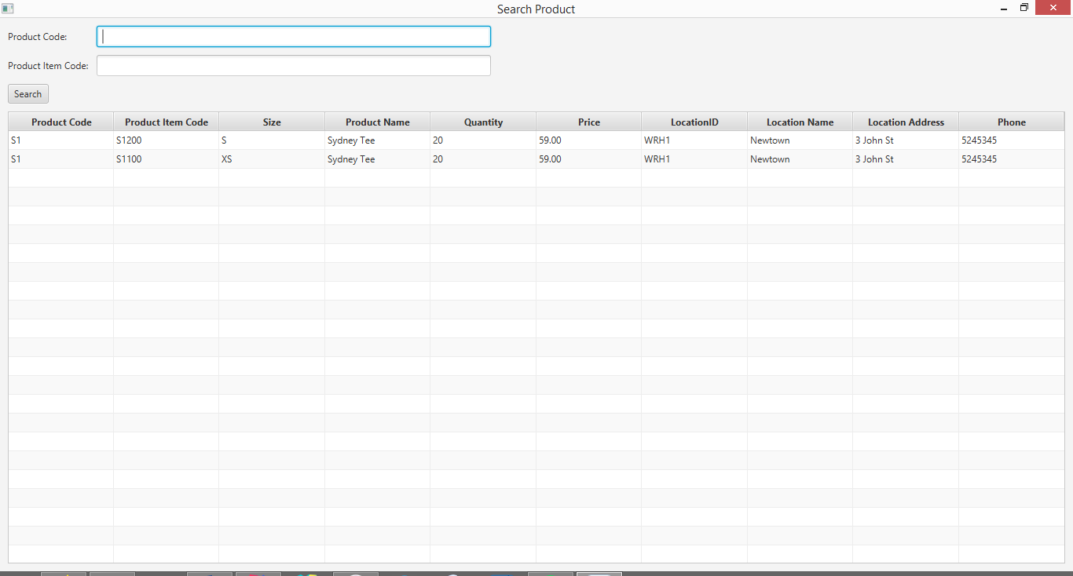

**Test Search Product Using Existing Product Code (Test Case SPT001) for Data Set 2:** **PASS**

### Data Set 3

|  |  |
| --- | --- |
| **Test Data Table** | |
|  | **Input Data** |
| **Product Code** | S2 |
| **Location ID** | STR2 |
| **Location Name** | Epping |

**Step 1**

* User opens the Search Product interface



**Step 2**

* User inputs “S2” to the Product Code field

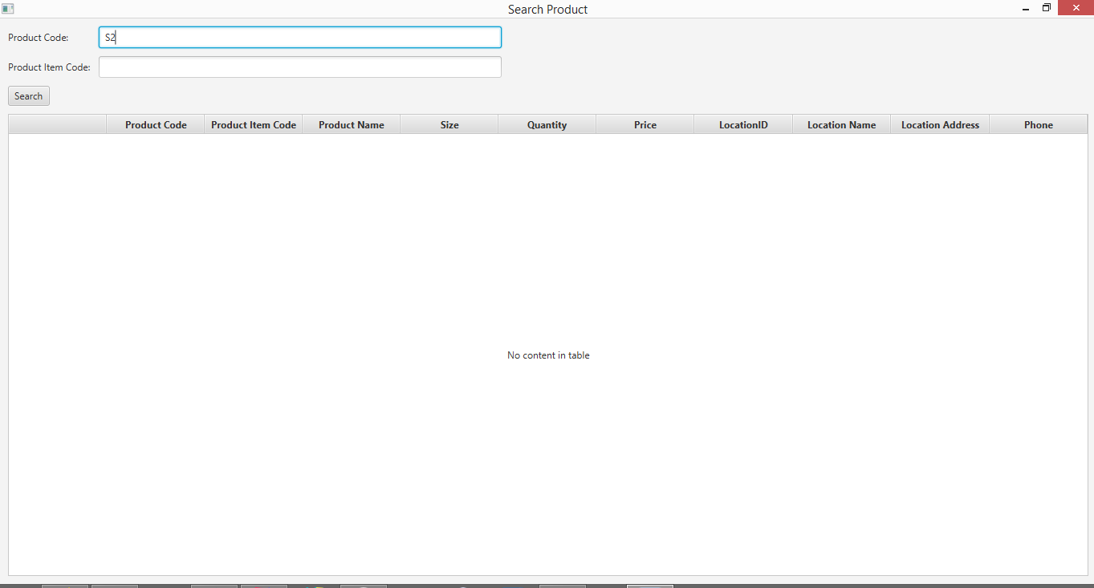

**Step 3**

* System display the details of matched product
* User selects the “Detail” button of the matched product in Location STR2

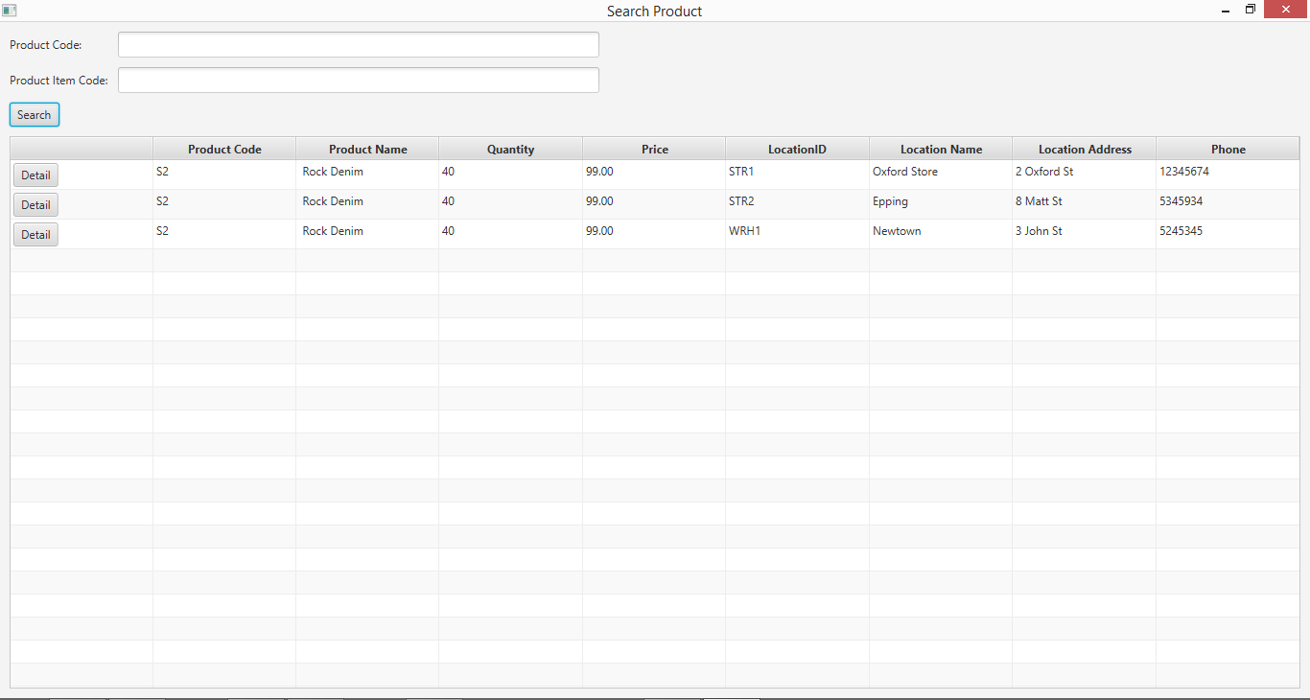

**Step 4**

* System displays the details of matched product items of selected product in STR2.

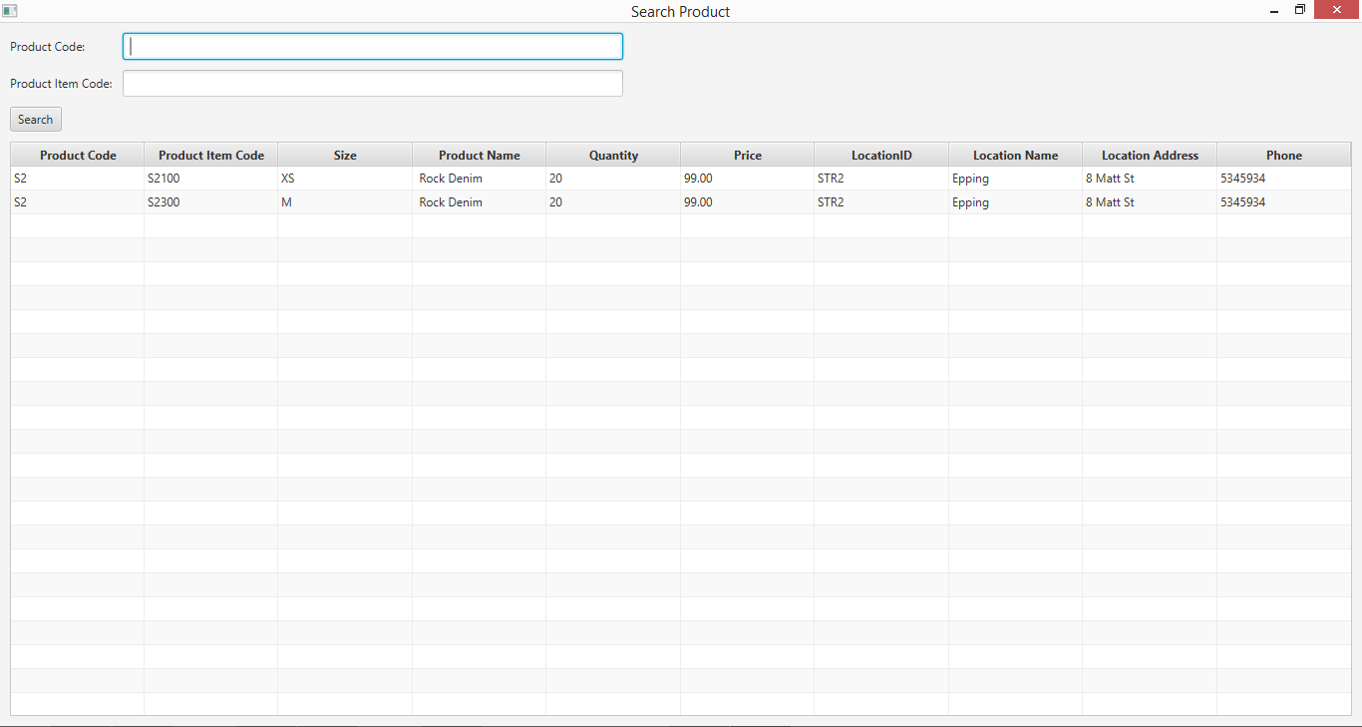

**Test Search Product Using Existing Product Code (Test Case SPT001) for Data Set 3:** **PASS**

# SPT002- Search Product Using Unknown Product Code

|  |  |  |  |  |  |
| --- | --- | --- | --- | --- | --- |
| **Test Name** | | Test Search Product Using Unknown Product Code (Test Case SPT002) | | | |
| **Use Case Tested** | | Search Product | | | |
| **Test Description** | | This test tests if the system can retrieve product item details and contents in each location using a random product code. This random product code value can be of any format i.e. it does not have to follow the product code format that has been prescribed by the business. | | | |
| **Pre-Conditions** | | Meta data must exist, product and product details like product code, product item code, location ID and so on must exist even though it may or may not be accessed which is based on the product code that will be entered. | | | |
| **Post-Conditions** | | If product code matches to the product code entry in the database, the matching product on each location is displayed through product code i.e. matching product is displayed through which product items belonging to the product is viewed. However, if product code does not match to any of the product code entry in the database, an appropriate message is displayed. | | | |
| **Notes** | | This test allows users to view product items using a product code.  This test shows appropriate messages are displayed for every user action (Addressing the usability requirement of the system). | | | |
| **Result (Pass/Fail/Warning/ Incomplete)** | | Pass | | | |
|  | **Test Step** | | **Expected Test Results** | **P** | **F** |
| 1. | Open the ABCInventoryClient.exe file | | ABCInventoryClient system launches. | P |  |
| 2. | Type in the product code in the product code field. | | System waits for the user to hit enter or click on the ‘Search’ button. | P |  |
| 3. | Hit enter or click on the ‘Search’ button. | | If product code matches with the product code entry in the database, product with matching product code is displayed with all other product details like total quantity, price, name, etc. along with the location details separated according to the location. | P |  |
|  |  | | If product code does not match with the product code entry in the database, an appropriate message is displayed notifying users that the product does not exist. | P |  |
| 4. | If Product Code matches click on details to check product item details in the desired location. | | Product Items’ details belonging to the product in the location that was selected is displayed. | P |  |

## Result Screenshots

The screenshots of the result on each test step for each data set are given below:

### Data Set 1

|  |  |
| --- | --- |
| **Test Data Table** | |
|  | **Input Data** |
| **Product Code** | A321 |
| **Location ID** | - |
| **Location Name** | - |

**Step 1**

* User opens the Search Product interface



**Step 2**

* User inputs “A321” to the Product Code field

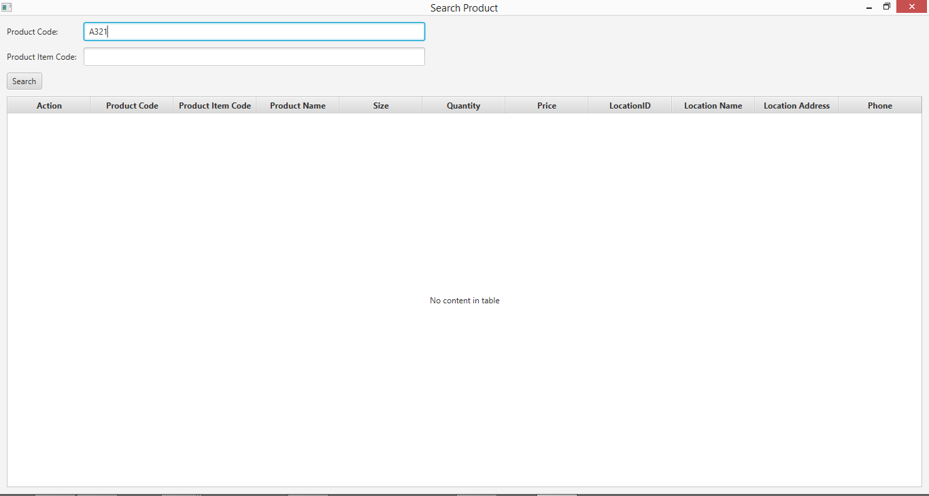

**Step 3**

* System pops up an alert to notify the searching Product Code does not exist.

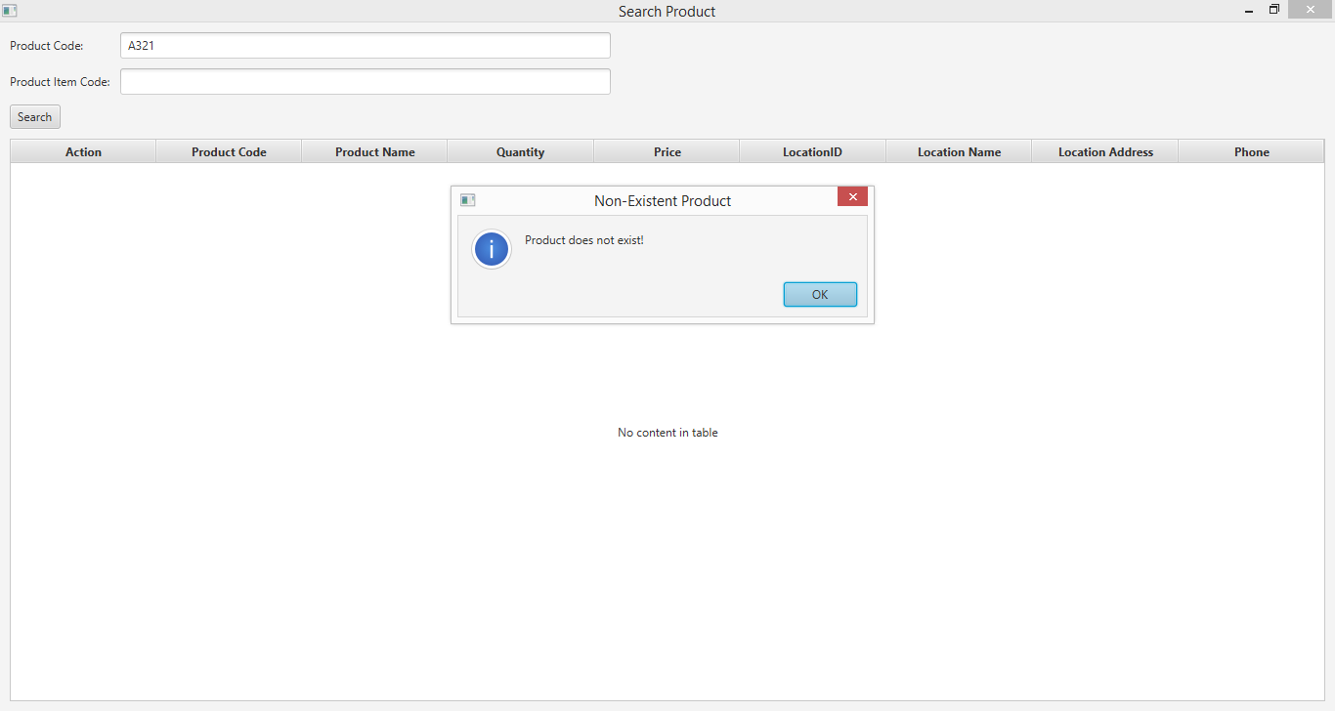

# **SPT002- Search Product Using Unknown Product Code for Data Set 1:** **PASS**

### Data Set 2

|  |  |
| --- | --- |
| **Test Data Table** | |
|  | **Input Data** |
| **Product Code** | S5 |
| **Location ID** | - |
| **Location Name** | - |

**Step 1**

* User opens the Search Product interface



**Step 2**

* User inputs “S5” to the Product Code field

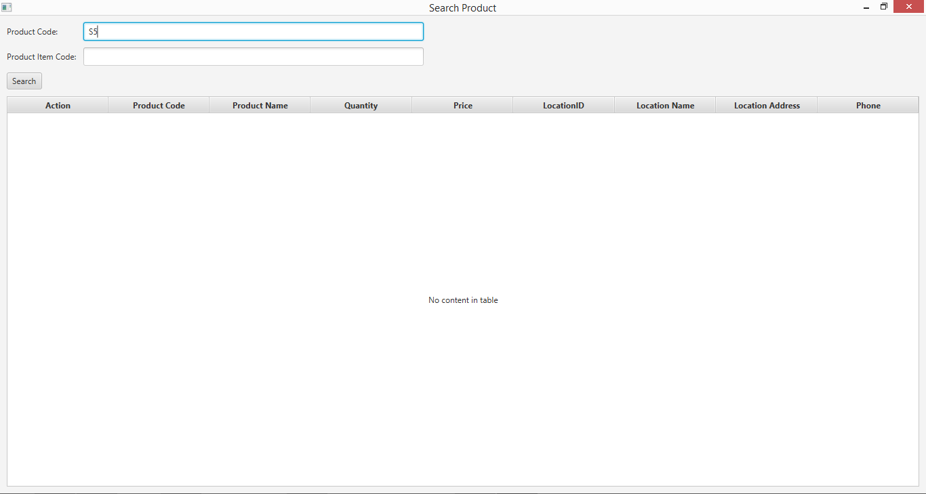

**Step 3**

* System pops up an alert to notify the searching Product Code does not exist.

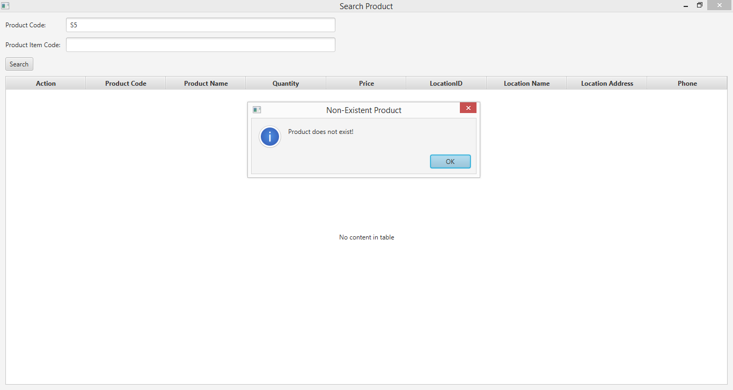

# **SPT002- Search Product Using Unknown Product Code for Data Set 2:** **PASS**

# SPT003- Search Product Using Existing Product Item Code

|  |  |  |  |  |  |
| --- | --- | --- | --- | --- | --- |
| **Test Name** | | Test Search Product Using Existing Product Item Code (Test Case SPT003) | | | |
| **Use Case Tested** | | Search Product | | | |
| **Test Description** | | This test tests if the system can retrieve product item details and contents in each location using a known product item. | | | |
| **Pre-Conditions** | | Meta data must exist, product and product details like product code, product item code, location ID and so on must exist. | | | |
| **Post-Conditions** | | Matching product item on displayed through product item code i.e. matching product is displayed through which product item code has been searched. | | | |
| **Notes** | | This test assumes that the user knows the product item code exists. | | | |
| **Result (Pass/Fail/Warning/ Incomplete)** | | Pass | | | |
|  | **Test Step** | | **Expected Test Results** | **P** | **F** |
| 1. | Open the ABCInventoryClient.exe file | | ABCInventoryClient system launches. | P |  |
| 2. | Type in the existing product item code that is known by the user in the Product Item Code field of the system. | | System waits for the user to hit enter or click on the ‘Search’ button. | P |  |
| 3. | Hit enter or click on the ‘Search’ button. | | Product with matching product item code is displayed with all other product details like total quantity, price, name, etc. | P |  |

## Result Screenshots

The screenshots of the result on each test step for each data set are given below:

### Data Set 1

|  |  |
| --- | --- |
| **Test Data Table** | |
|  | **Input Data** |
| **Product Item Code** | S1100 |

**Step 1**

* Open the Search Product interface

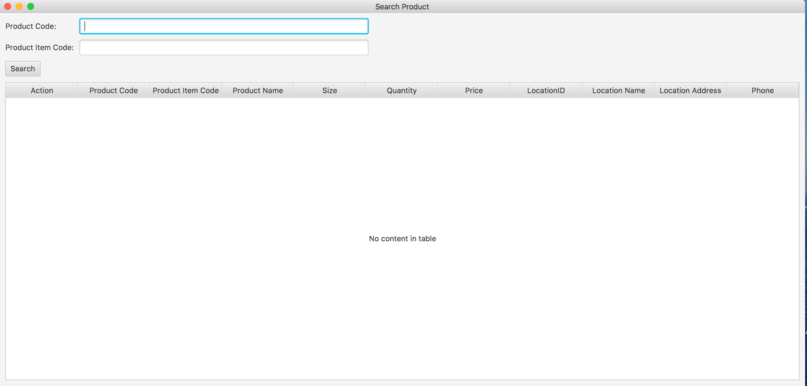

**Step 2**

* User inputs “S1100” to the Product Item Code field

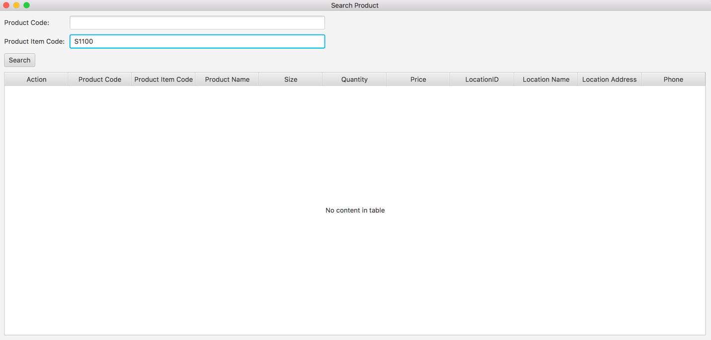

**Step 3**

* System displays the details of matched product items.

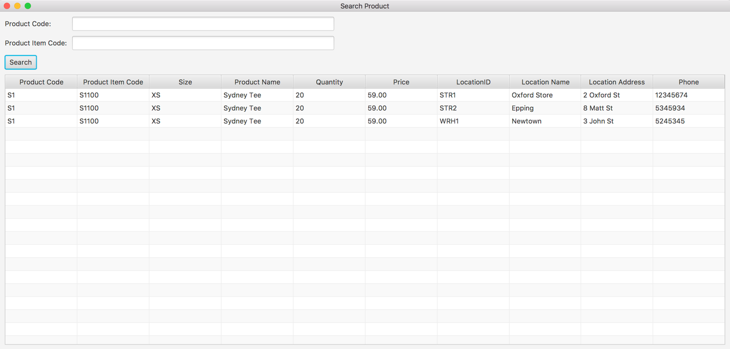

# **SPT003- Search Product Using Existing Product Item Code for Data Set 1: PASS**

### Data Set 2

|  |  |
| --- | --- |
| **Test Data Table** | |
|  | **Input Data** |
| **Product Item Code** | S1200 |

**Step 1**

* Open the Search Product interface



**Step 2**

* User inputs “S1200” to the Product Item Code field

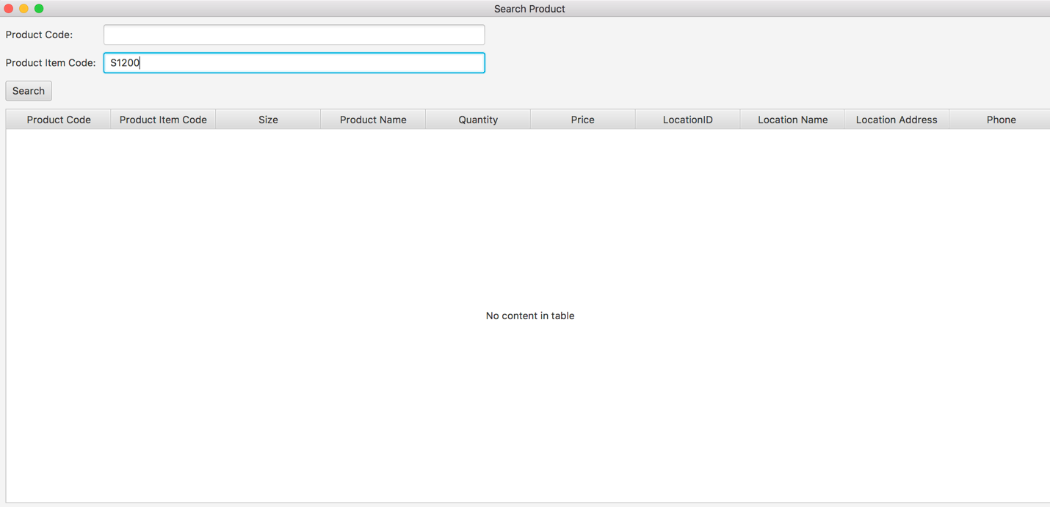

**Step 3**

* System displays the details of matched product items.

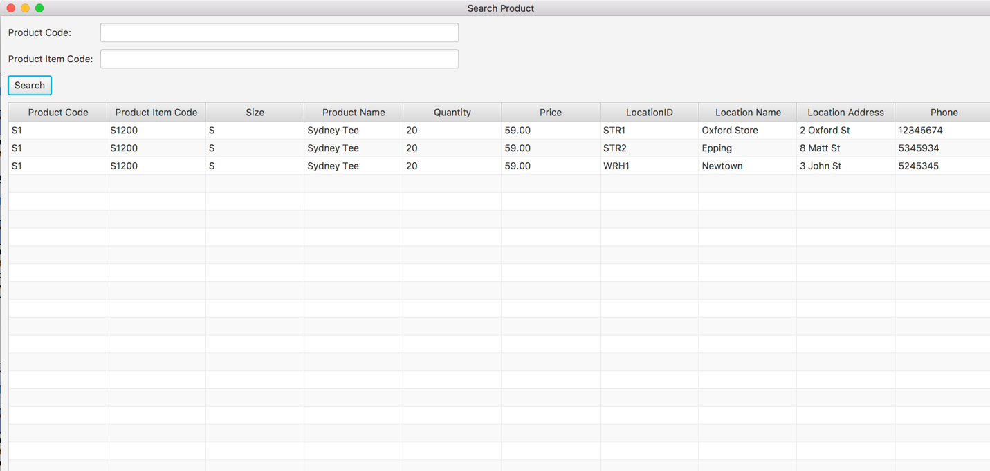

# **SPT003- Search Product Using Existing Product Item Code for Data Set 2: PASS**

### Data Set 3

|  |  |
| --- | --- |
| **Test Data Table** | |
|  | **Input Data** |
| **Product Item Code** | S2100 |

**Step 1**

* Open the Search Product interface



**Step 2**

* User inputs “S2100” to the Product Item Code field

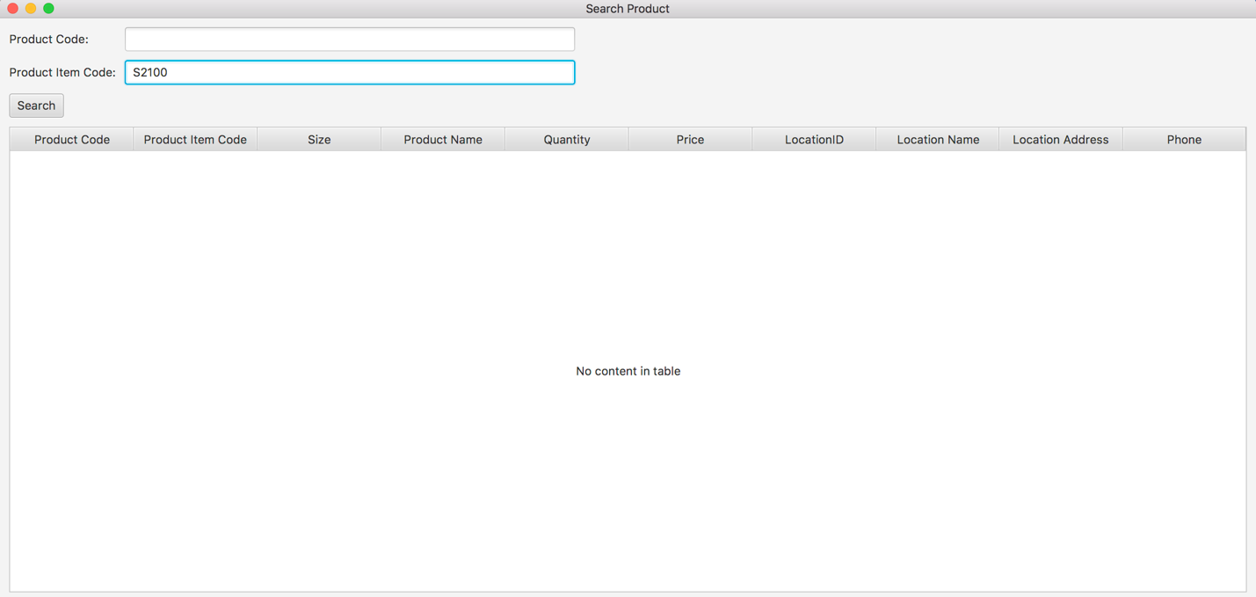

**Step 3**

* System displays the details of matched product items.

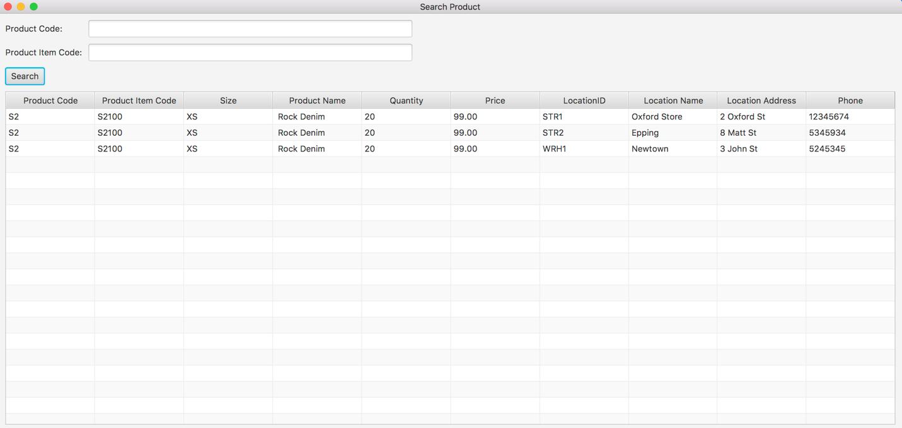

# **SPT003- Search Product Using Existing Product Item Code for Data Set 3: PASS**

# SPT004- Search Product Using Unknown Product Item Code

|  |  |  |  |  |  |
| --- | --- | --- | --- | --- | --- |
| **Test Name** | | Test Search Product Using Unknown Product Item Code (Test Case SPT004) | | | |
| **Use Case Tested** | | Search Product | | | |
| **Test Description** | | This test tests if the system can retrieve product item details and contents in each location using a unknown product item. | | | |
| **Pre-Conditions** | | N/a | | | |
| **Post-Conditions** | | The alert will be popped up to display the message that notify user the searching product item code does not exist in system. | | | |
| **Notes** | | This test assumes that the user try to search the product item code randomly. | | | |
| **Result (Pass/Fail/Warning/ Incomplete)** | | Pass | | | |
|  | **Test Step** | | **Expected Test Results** | **P** | **F** |
| 1. | Open the ABCInventoryClient.exe file | | ABCInventoryClient system launches. | P |  |
| 2. | Type in the random product item code in the Product Item Code field of the system. | | System waits for the user to hit enter or click on the ‘Search’ button. | P |  |
| 3. | Hit enter or click on the ‘Search’ button. | | An alert message will be displayed to let user know the searching product item does not exist in system. | P |  |

# Result Screenshots

The screenshots of the result on each test step for each data set are given below:

### Data Set 1

|  |  |
| --- | --- |
| **Test Data Table** | |
|  | **Input Data** |
| **Product Item Code** | SJSAJO |

**Step 1**

* Open the Search Product interface

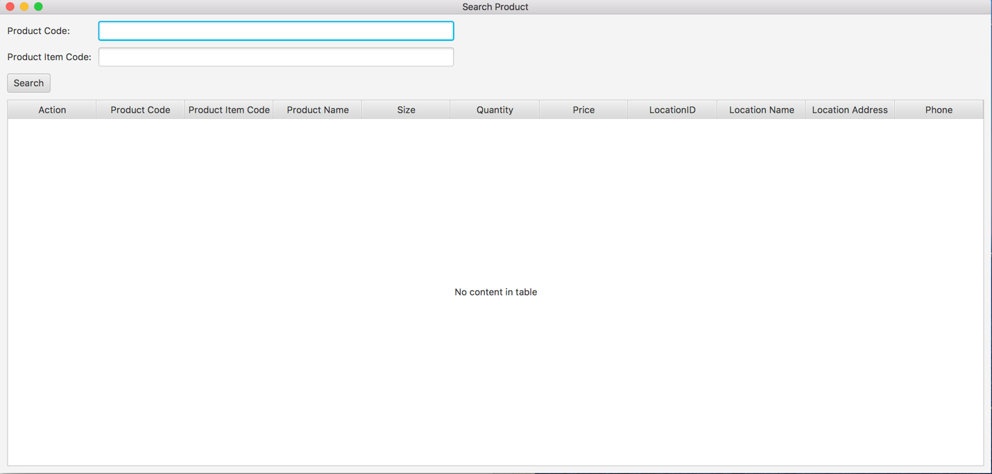

**Step 2**

* User inputs “SJSAJO” to the Product Item Code field

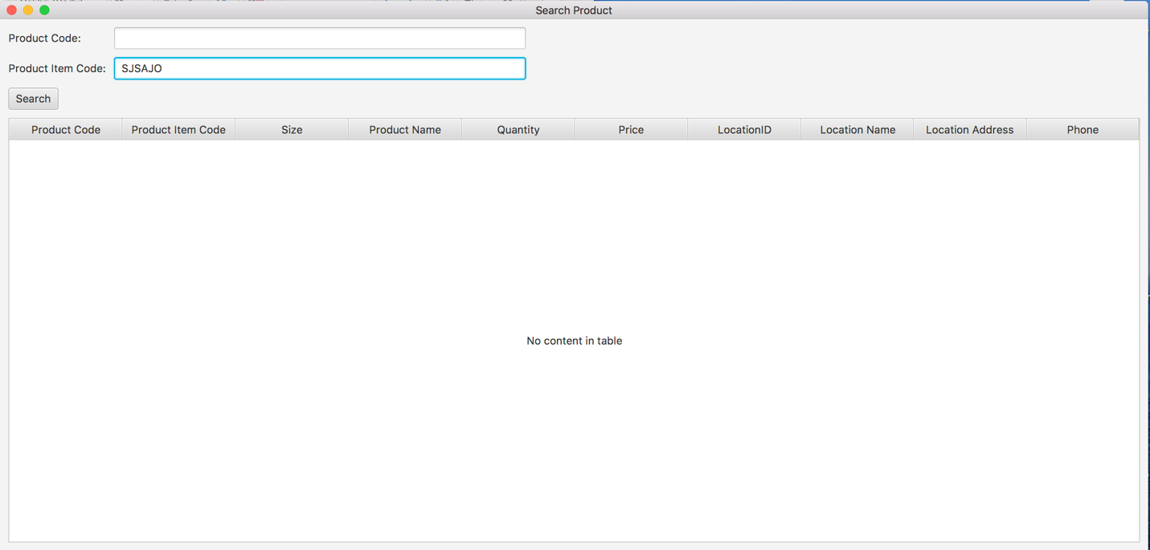

**Step 3**

* System pops up an alert to notify the searching Product Item Code does not exist.

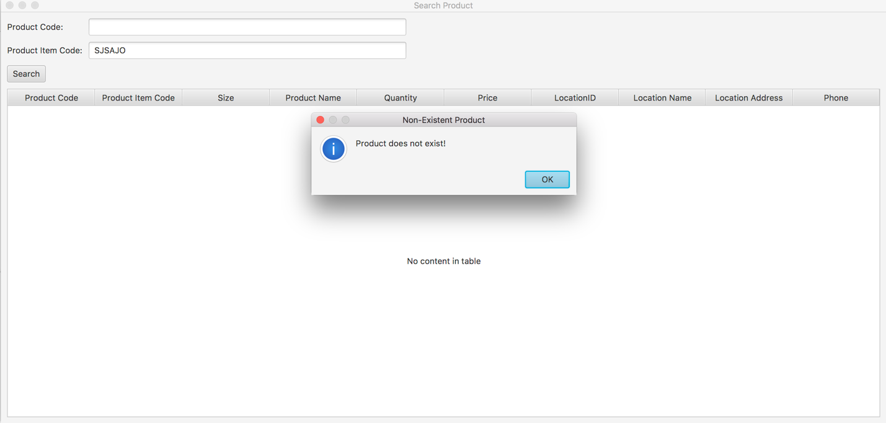

# **SPT004- Search Product Using Unknown Product Item Code for Data Set 1:** **PASS**

### Data Set 2

|  |  |
| --- | --- |
| **Test Data Table** | |
|  | **Input Data** |
| **Product Item Code** | S23022 |

**Step 1**

* Open the Search Product interface



**Step 2**

* User inputs “S23022” to the Product Item Code field

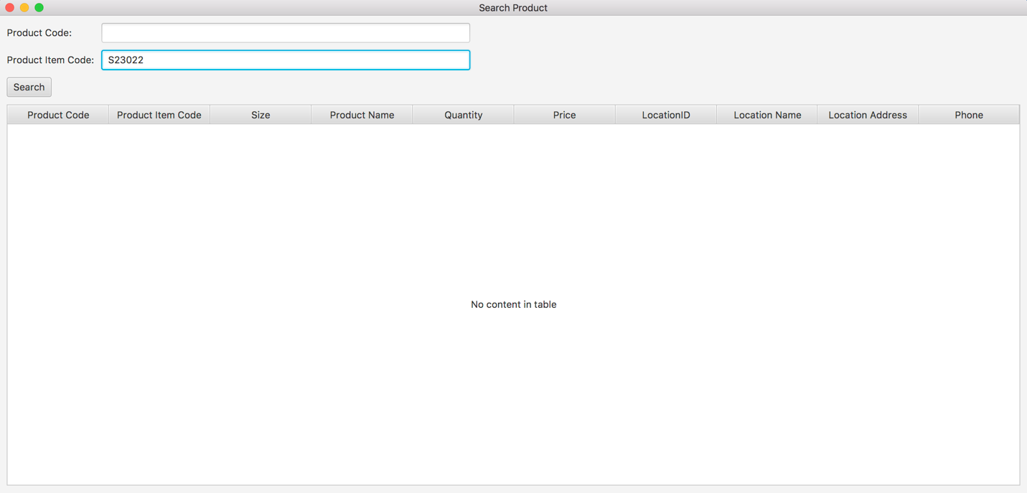

**Step 3**

* System pops up an alert to notify the searching Product Item Code does not exist.

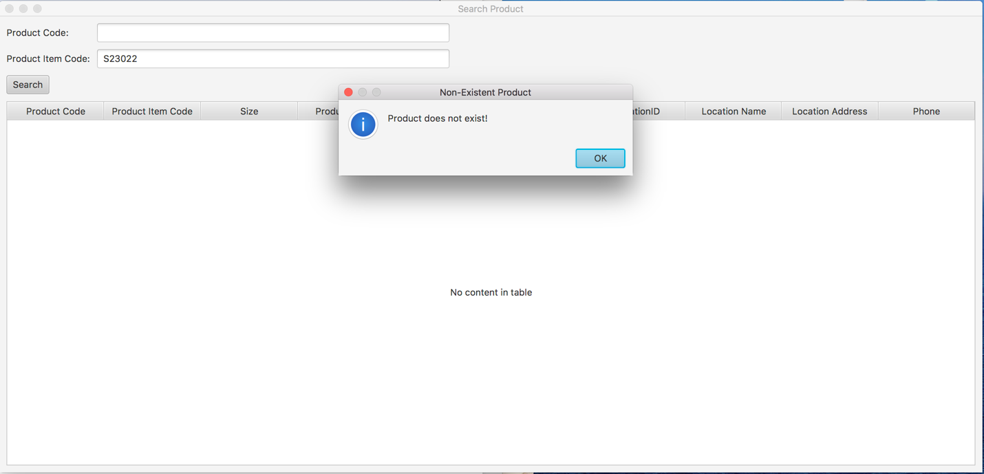

# **SPT004- Search Product Using Unknown Product Item Code for Data Set 2:** **PASS**

### Data Set 3

|  |  |
| --- | --- |
| **Test Data Table** | |
|  | **Input Data** |
| **Product Item Code** | S2AB |

**Step 1**

* Open the Search Product interface



**Step 2**

* User inputs “S2AB” to the Product Item Code field

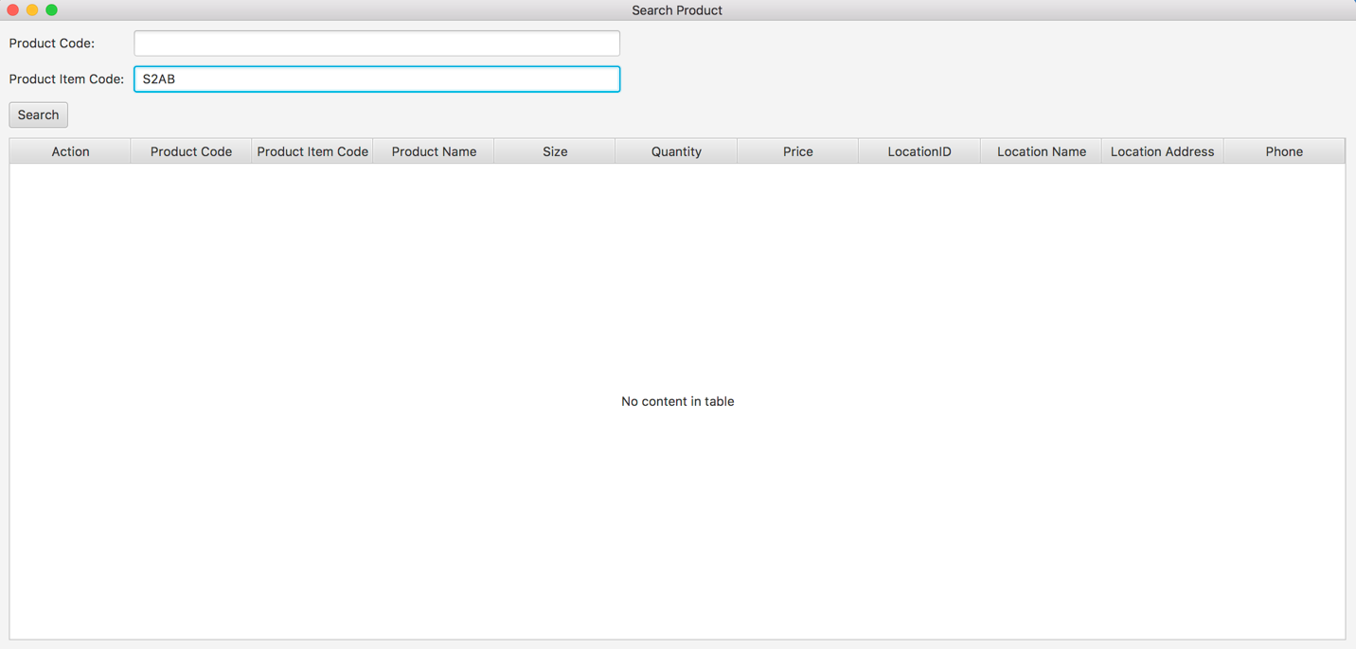

**Step 3**

* System pops up an alert to notify the searching Product Item Code does not exist.

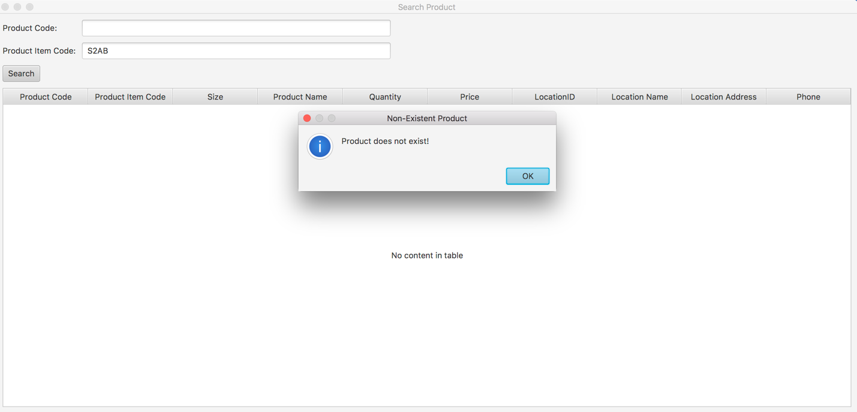

# **SPT004- Search Product Using Unknown Product Item Code for Data Set 3:** **PASS**

# SPT005- Click on Search button without entering any Product Item Code or Product Code values

|  |  |  |  |  |  |
| --- | --- | --- | --- | --- | --- |
| **Test Name** | | Click on Search button without entering any Product Item Code or Product Code values (Test Case SPT005) | | | |
| **Use Case Tested** | | Search Product | | | |
| **Test Description** | | This test tests the outcome of clicking on the ‘Search’ button without entering any values in the Product Code and Product Item Code field. | | | |
| **Pre-Conditions** | | - | | | |
| **Post-Conditions** | | Appropriate message is displayed. | | | |
| **Notes** | | - | | | |
| **Result (Pass/Fail/Warning/ Incomplete)** | | Pass | | | |
|  | **Test Step** | | **Expected Test Results** | **P** | **F** |
| 1. | Open the ABCInventoryClient.exe file | | ABCInventoryClient system launches. | P |  |
| 2. | Click on ‘Search’ button without entering any values for product code and product item code. | | System displays a message prompting user to enter the product code or the product item code. | P |  |

## Result Screenshots

|  |  |
| --- | --- |
| **Test Data Table** | |
|  | **Input Data** |
| **Product Code** | - |
| **Product Item Code** | - |

The screenshots of the result on each test step for the test are as follows:

**Step 1**

* Open the Search Product interface



**Step 2**

* System pops up an alert to notify the Product Item Code field and Product Code field need to be filled to search a product.

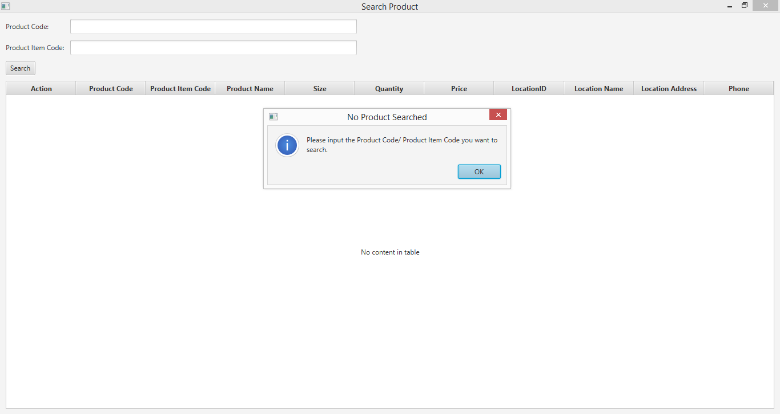

# **SPT005- Click on Search button without entering any Product Item Code or Product Code values: PASS**

# SPT006- Test output when both Product Code and Product Item Code field are filled to search for a product.

|  |  |  |  |  |  |
| --- | --- | --- | --- | --- | --- |
| **Test Name** | | Test output when both Product Code and Product Item Code field are filled to search for a product. (Test Case SPT006) | | | |
| **Use Case Tested** | | Search Product | | | |
| **Test Description** | | This test tests the outcome of clicking on the searching for a product by entering both product code and product item code field. | | | |
| **Pre-Conditions** | | Meta data must exist. | | | |
| **Post-Conditions** | | Appropriate message is displayed. | | | |
| **Notes** | | Product code and product item code entered may or may not exist in the database. | | | |
| **Result (Pass/Fail/Warning/ Incomplete)** | | Pass | | | |
|  | **Test Step** | | **Expected Test Results** | **P** | **F** |
| 1. | Open the ABCInventoryClient.exe file | | ABCInventoryClient system launches. | P |  |
| 2. | Enter Product Code in the product code field. | | System waits for user to hit the ‘Search’ button. | P |  |
| 3. | Enter Product Item code in the product item code field. | | System waits for user to hit the ‘Search’ button. | P |  |
| 4. | User enters the ‘Search’ button. | | System displays a message notifying the user not to enter product code and product item code at the same time for searching. | P |  |

## Result Screenshots

The screenshots of the result on each test step for each data set are given below:

### Data Set 1

|  |  |
| --- | --- |
| **Test Data Table** | |
|  | **Input Data** |
| **Product Code** | S1 |
| **Product Item Code** | S1100 |

**Step 1**

* Open the Search Product interface



**Step 2**

* User inputs “S1” to the Product Code field

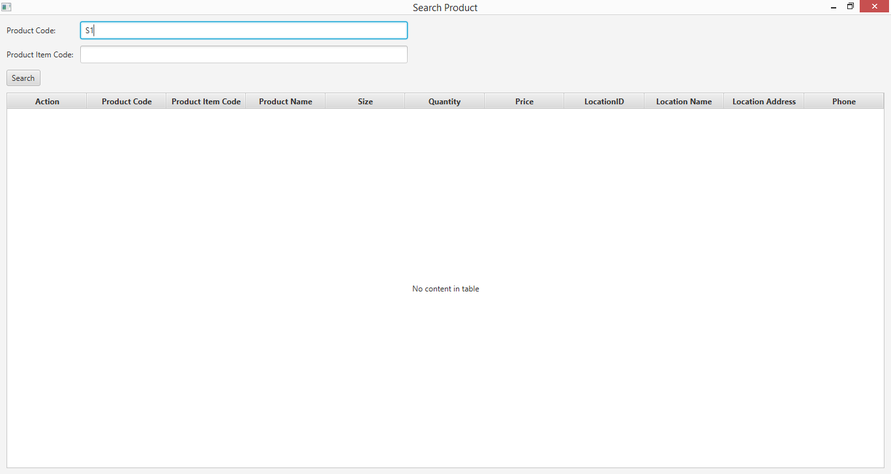

**Step 3**

* User inputs “S1100” to the Product Item Code field

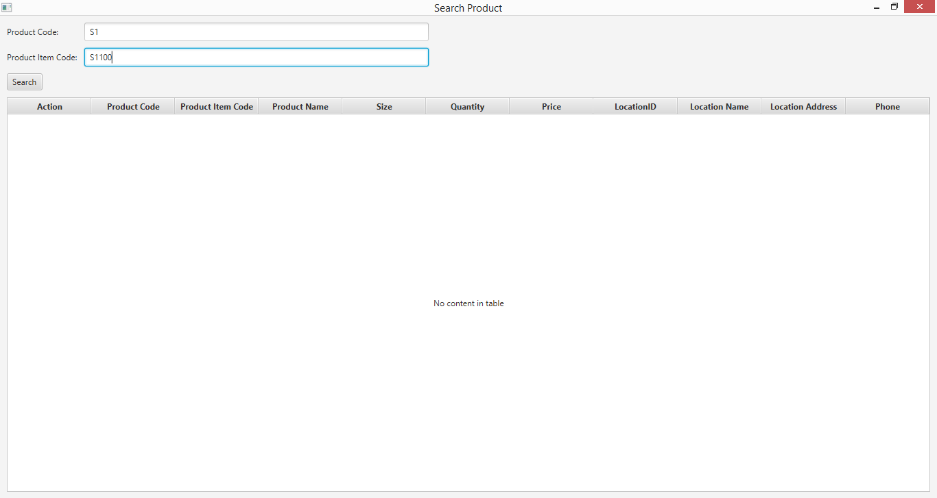

**Step 4**

* System pops up an alert to notify user cannot search the Product Code and Product Item Code at the same time.

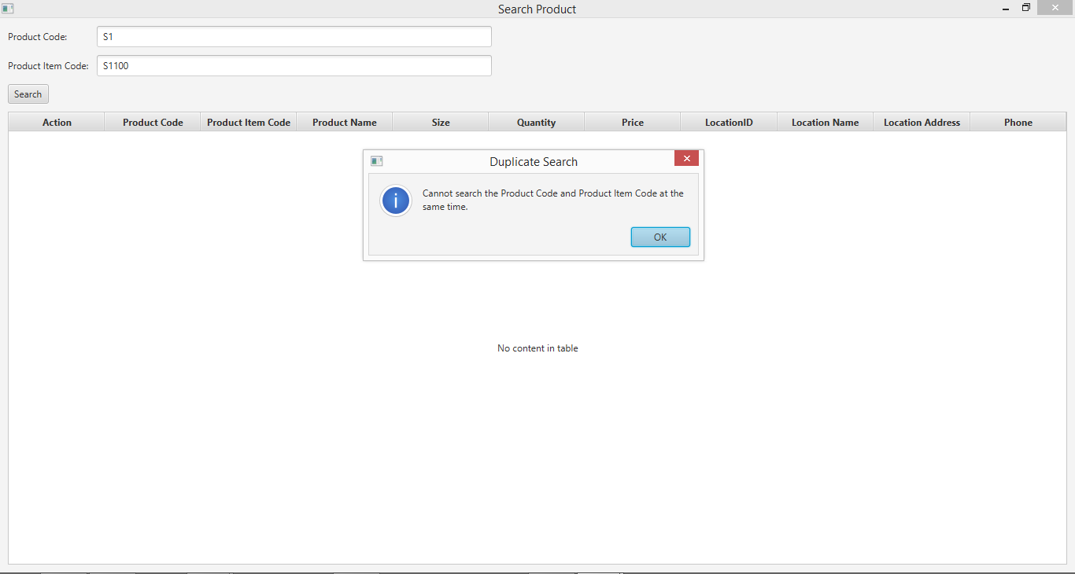

# **SPT006- Test output when both Product Code and Product Item Code field are filled to search for a product for Data Set 1: PASS**

### Data Set 2

|  |  |
| --- | --- |
| **Test Data Table** | |
|  | **Input Data** |
| **Product Code** | S3 |
| **Product Item Code** | S3200 |

**Step 1**

* Open the Search Product interface



**Step 2**

* User inputs “S3” to the Product Code field

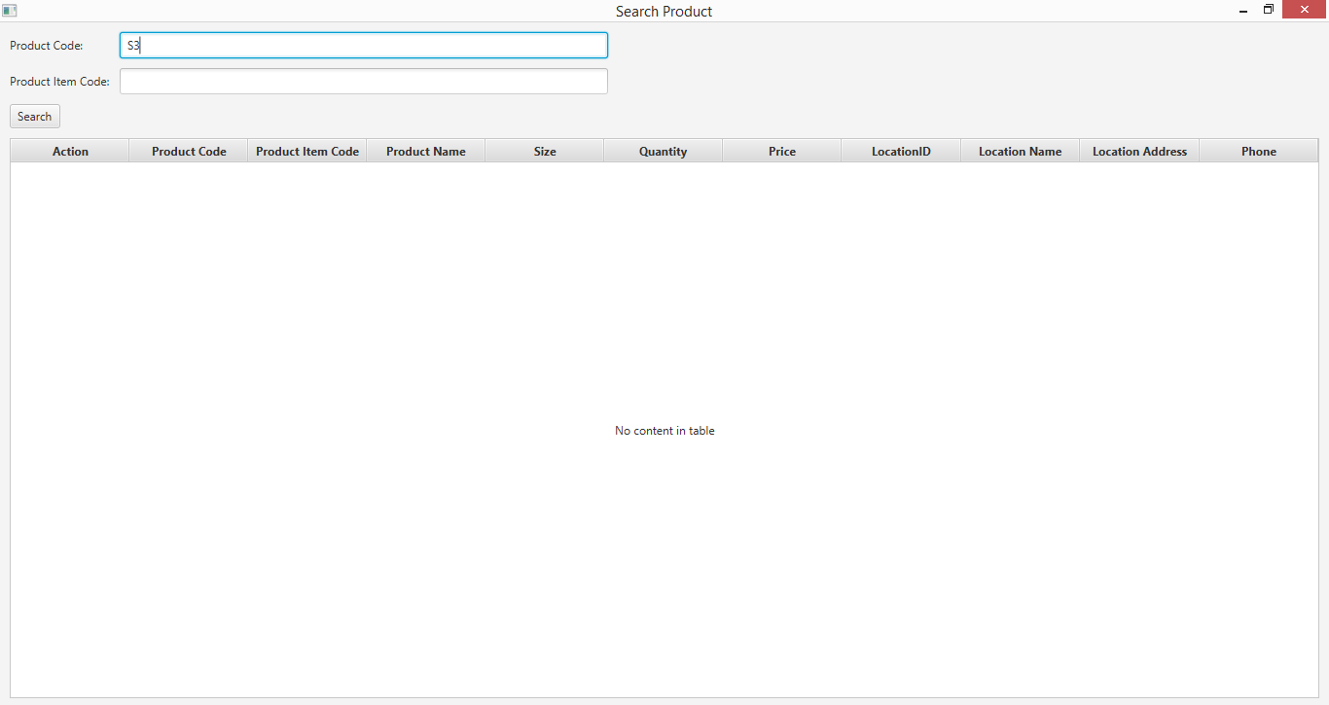

**Step 3**

* User inputs “S3200” to the Product Item Code field

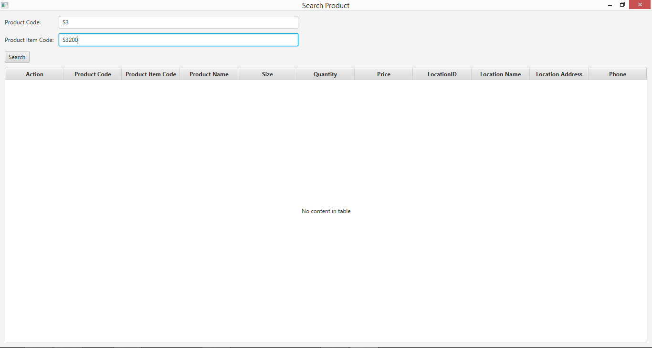

**Step 4**

* System pops up an alert to notify user cannot search the Product Code and Product Item Code at the same time.

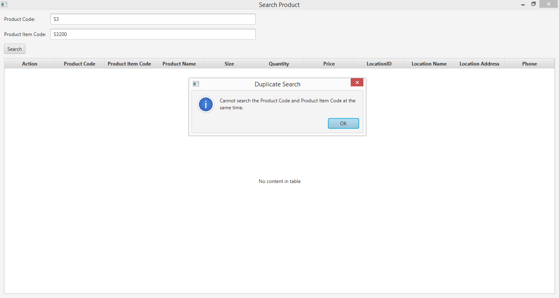

# **SPT006- Test output when both Product Code and Product Item Code field are filled to search for a product for Data Set 2: PASS**

### Data Set 3

|  |  |
| --- | --- |
| **Test Data Table** | |
|  | **Input Data** |
| **Product Code** | RT43 |
| **Product Item Code** | RT43501 |

**Step 1**

* Open the Search Product interface



**Step 2**

* User inputs “RT43” to the Product Code field

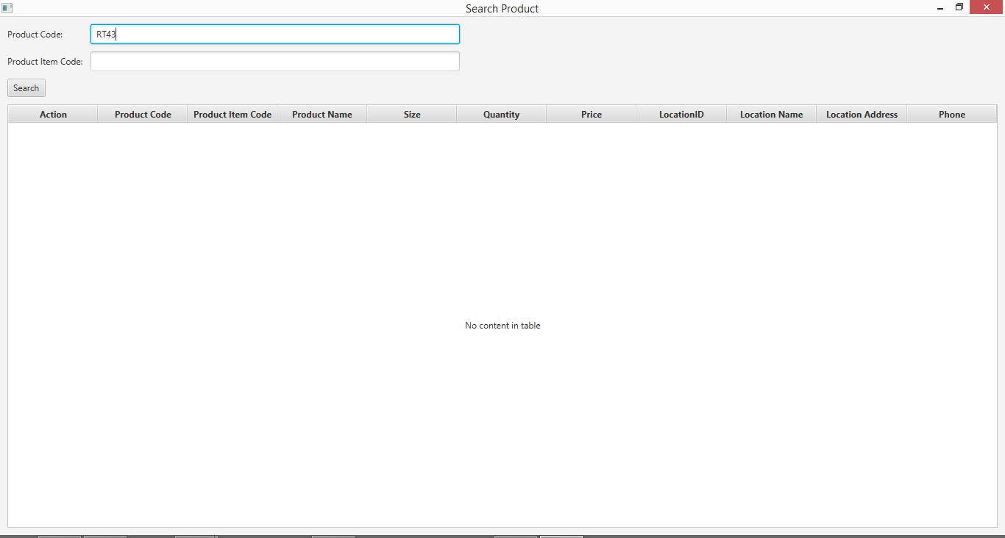

**Step 3**

* User inputs “RT43501” to the Product Item Code field

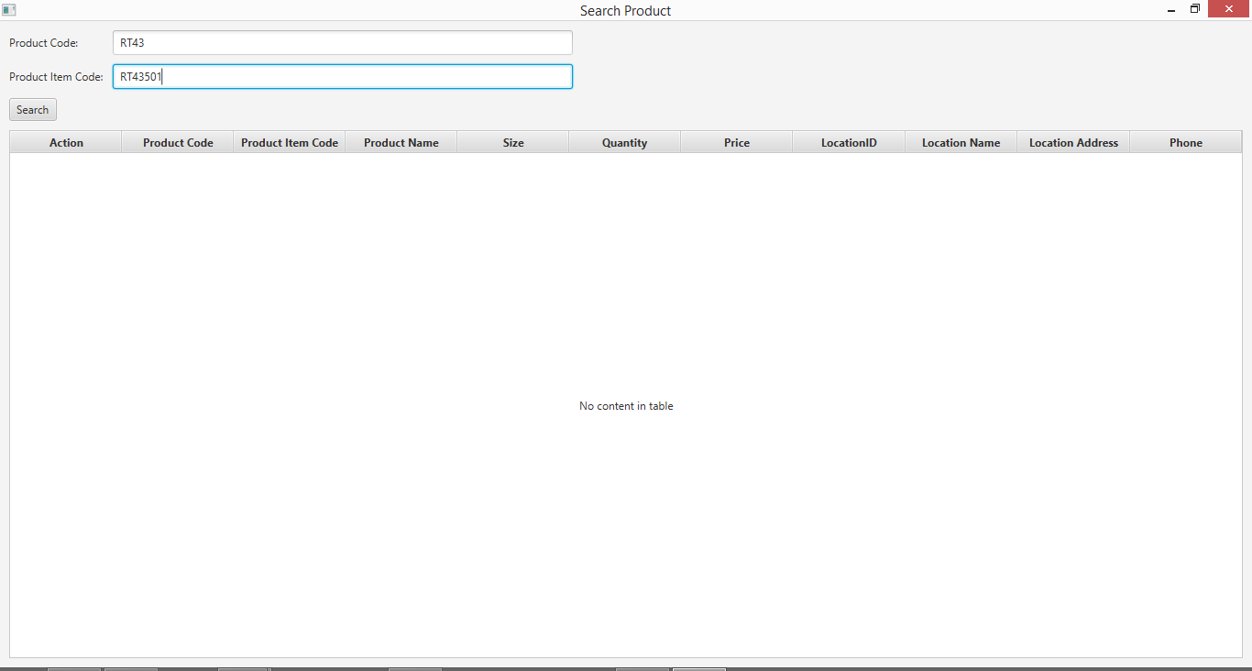

**Step 4**

* System pops up an alert to notify user cannot search the Product Code and Product Item Code at the same time.

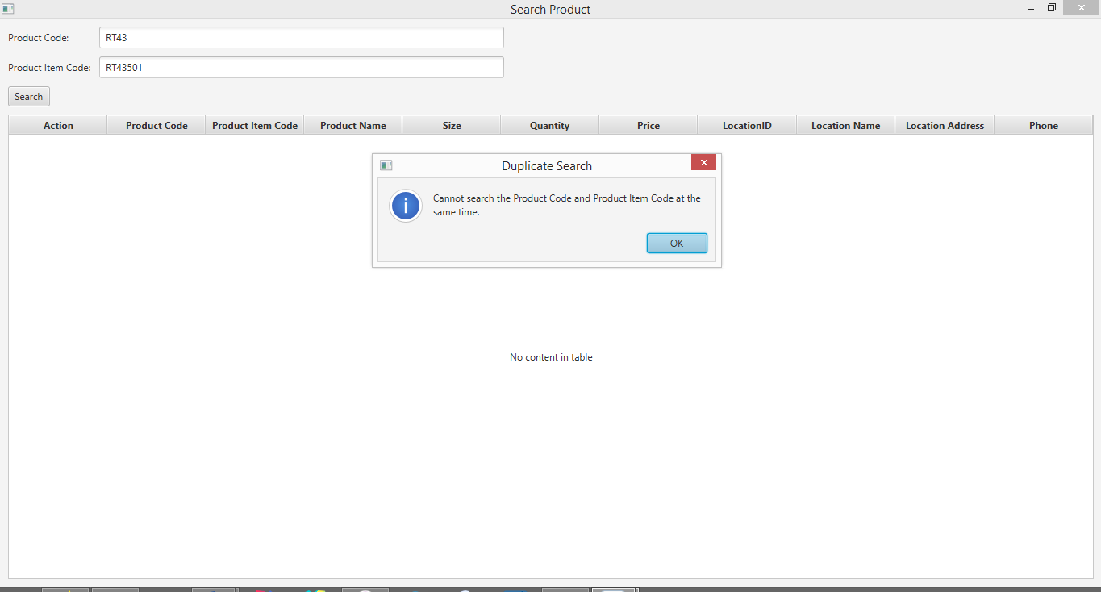

# **SPT006- Test output when both Product Code and Product Item Code field are filled to search for a product for Data Set 3: PASS**